login*update 24 Feb 2026
- name will be “Connector Tag” with a space between the two words, and capitalisation of both C and T.
- Terms of Service, Privacy Policy, and Subscription and Cancellation Policy has been drafted (date yet to be included), see email from Daniel
- Automatic emails to users have been drafted, see email from Daniel

Connector Tag (Stage 1.0 - Developing the WebApp MVP)
Written by Daniel Yap
(VERSION 3 - 5 JANUARY 2026)
Private & Confidential - for intended recipient only

Connector Tag Web App - Specification Document (SRS) for Stage 1.0
___________________________________________________________________________________

- Introduction
  - Name: “Connector Tag” with a space between the two words, and capitalisation of both C and T.
  - Domain name: www.connectortag.com
  - Description: SaaS webapp, freemium model (2 versions - free and PRO).
    - Only users in Australia will be given the option to upgrade to PRO in MVP
    - This will be done using Stripe’s functions of:
      - Billing address requiring an Australian address, and
      - Only accept cards issued by Australian banks
  - Function: Allow users to sit back (no swiping like Tinder) and let the algo match them with other users in a specified location by using the same tag(s). Once matched, users can message each other. Messaging in MVP will be text-based, no photos or media can be sent.
  - Target market: Individual users (but also businesses) looking to connect with other individual users in a specified location, based on some commonality (tag).
  - Geographical market: Global, but MVP will limit tags to ‘Latin script’ and to ten initial locations as follows.
🇦🇺 Sydney
🇦🇺 Melbourne
🇦🇺 Brisbane
🇦🇺 Perth
🇦🇺 Adelaide
🇦🇺 Gold Coast
🇸🇬 Singapore
🇬🇧 London
🇺🇸 New York City, NY
🇺🇸 Los Angeles, CA
  - Definition:
      - ‘Tag’ is a keyword or search term that a User is required to create to identify with their account so that the algo can match them with other users in a specified location.
    - ‘User’ refers to the person using the account.
    - ‘Matched-User’ refers to another user who has matched with the User.
    - A ‘match’ occurs if two users in the same location use the exact same tag(s):
      - subject to satisfying each user’s ‘minimum number of matching tags’ rule, whichever one is higher
      - exact match is required, but capitalisation is ignored
    - ‘Minimum number of matching tags’ is a rule that a PRO user can set, but for a free user is set to 2 by default. (For example, A is a free user and B is a PRO user who has set this rule to 3. A and B have 2 tags that exactly match. Users A and B will not be matched by the algo because although the rule is satisfied for A, the rule is not satisfied for B.)
    - ‘Location’ is limited to a set list of cities from which a User must select one. It is NOT the actual/GPS location of a User, hence, a User is able to select a location that is not their actual location.
    - ‘Profile picture’ is an image that a User can upload to their account and is viewable by the User themself, Matched-Users and Admin only, not to every user on the site.
    - ‘Admin’ refers to Daniel or any future staff of ConnectorTag.
    - ‘Logo’ for ConnectorTag that is to be used on every page has been provided to you. Kindly code this as referring to an image, so that it will be easy if Logo is changed in the future. The logo with full name is to be used on the landing page. The shorter logo is to be used on every page at the top-left corner as navigational sidebar, and also as browser favicon.
  - Stages and Goals:
    - Stage 1.0 (where we are now)
      - Develop the MVP
        - Build a scalable back-end infrastructure
        - Keep scope minimal to reduce developmental cost
      - Test the market
        - Validate interest-based matching model
        - Determine if city-level user density is attainable
        - Test conversion to PRO in Australia
        - Receive user feedback for improvements
      - Raise revenue from PRO subscriptions from Australian users only
    - Stage 2.0+ (not now, just for consideration when doing the build)
      - Improve on functionalities and security of the WebApp.
      - Consider if mobile apps should be developed.
      - With the help of AI or other technology, allow for matches of words that are related
        - e.g. swim, swimmer, swimming (same root word)
        - e.g. Christian, church, Jesus (more advanced)

- Overall Description
  - ConnectorTag will have the following pages:
    - Landing page - where a User signs up/signs in
    - My tags page
      - Free version - requiring a User to enter 5 tags; ‘minimum number of matching tags’ is set to 2 by default for free accounts.
      - PRO version - allowing a User to enter 5-12 tags; ‘minimum number of matching tags’ set to 1-12 subject to User preference.
    - Popular tags page - where a User can view the most popular tags used by other users in the same location.
    - My matches page:
      - If no Matched-User:
        - free version wording
        - PRO version wording
      - With at least one Matched-User
    - My messages page - per Matched-User
    - Upgrade to PRO page:
      - New user wording
      - Free trial used wording
    - My Profile page
    - Super Admin Page
    - Navigational sidebar
      - Instead of having the navigation as buttons at the bottom of the screen, users navigate the site, from any page except the landing page, by hovering over (if accessed by computer only)/clicking the logo (mobile/computer) on the top-left of the screen and then clicking one of the icons that pops-up below the logo. See design below.
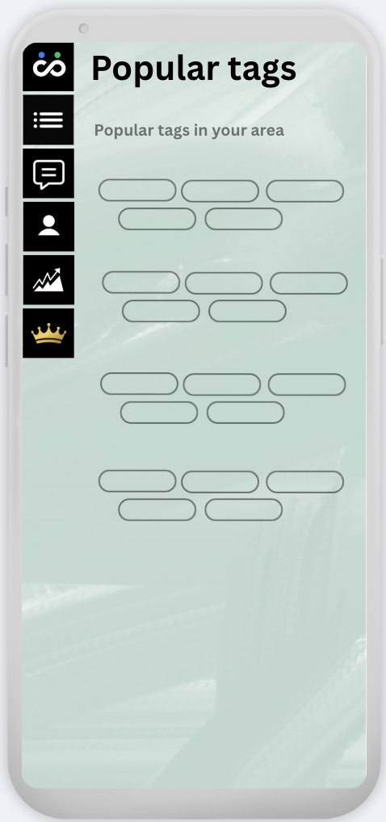
      - When a User hovers over/clicks the logo, the 5 black boxes below the logo pops-up on the screen and become clickable for the User.
        - My idea is for the rest of the wording on the page to become semi-transparent and unclickable like in the image above, but if this takes a lot of time to do, then this part is not necessary.
      - The 5 black boxes are (in order from top to bottom):
        - My Tags
        - My Matches.
          - Note that the ‘My Messages’ page (individualised to every Matched-User) can only be accessed from the ‘My Matches’ screen.
        - My Profile
        - Popular Tags
        - Upgrade to PRO.
          - This box icon no longer appears when a user becomes a PRO user.
      - Also, note that all the wording on every screen should be slightly more to the right-side, so as not to be covered by the navigational sidebar, as in image above. Please take this into consideration when doing the design.

- Landing Page

  - Design below is the landing page for any User who visits www.connectortag.com
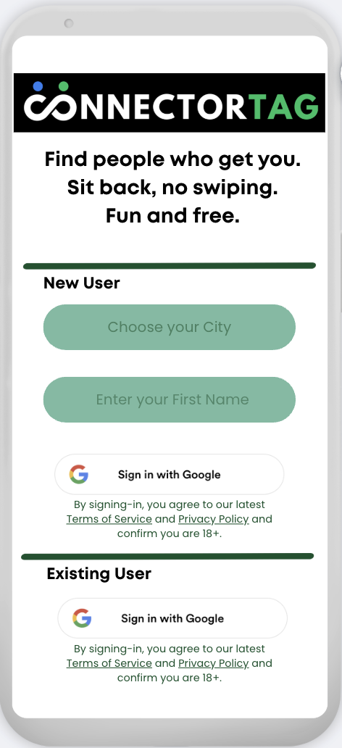
  - Links to ‘Terms of Service’ and ‘Privacy Policy’ when clicked, will open as a modal pop-up, with an X at the top-right to close it.
Any error messages are to be displayed in red near the respective field/button

  - New Users will be required to:
    - Choose your City
      - which when clicked on, opens the following modal pop-up
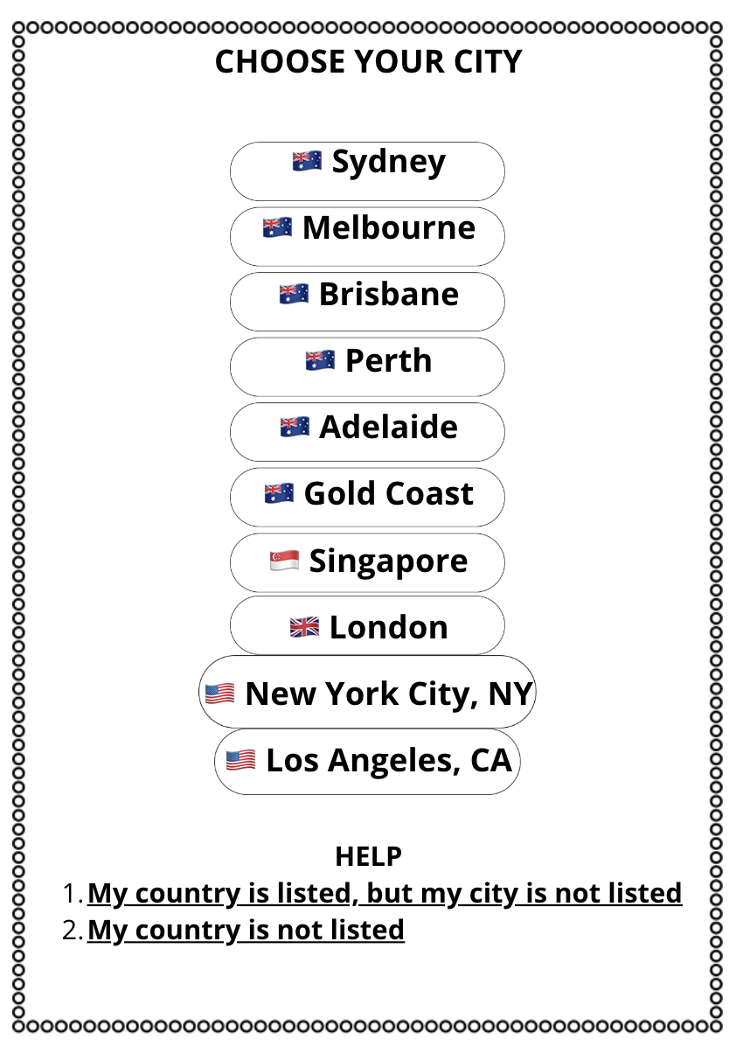
      - All modal pop-ups should have a small X at top-right to close the modal pop-up.
      - If a user clicks on any one of the listed cities, this modal pop-up closes and the name of the city with the country flag appears on the landing page, instead of the placeholder “Choose your City”.
        - User can click on the box again to change the city, say if they made a mistake and selected the wrong city.
      - If user clicks on HELP “1……..”, open another modal pop-up over this showing the following
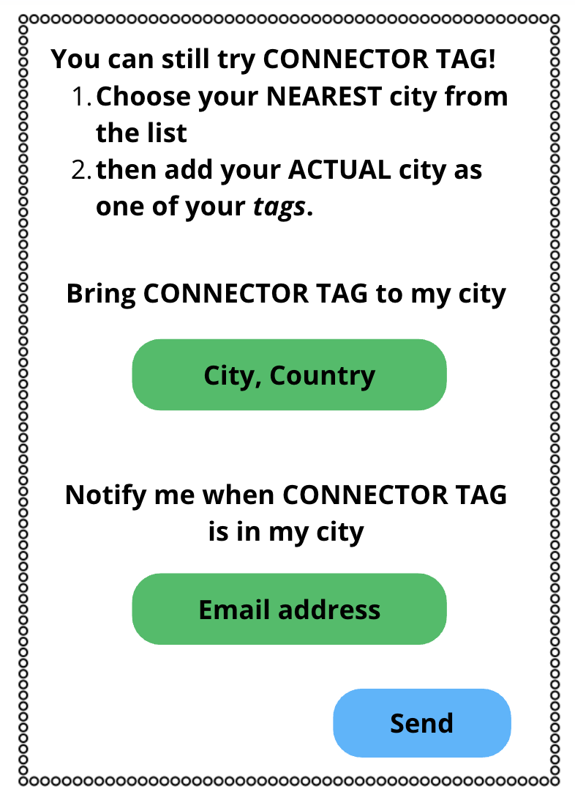
        - The words in the green boxes are ‘placeholders’ that disappears once a user starts typing in the box
        - Clicking the blue Send box will add the user’s email address and city,country data entered into the ‘Waiting List’, and will close the modal pop-up.
- If user clicks on HELP “2……..”, open another modal pop-up over this showing the following
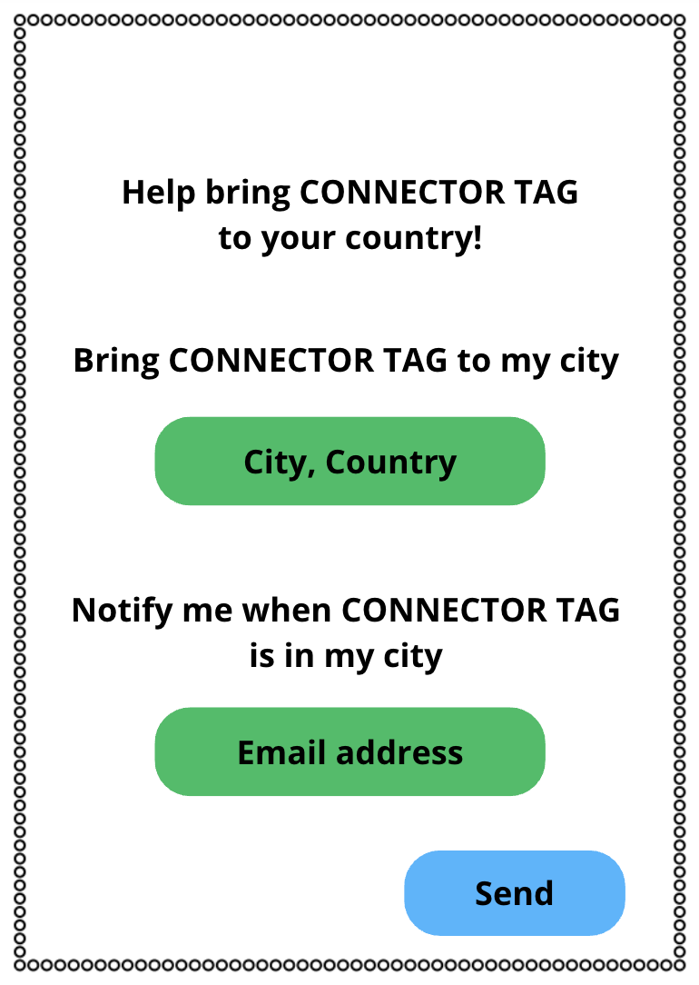

    - Enter your first name
      - is initially an empty free-text field
      - that when clicked, opens up the mobile keyboard on a mobile or tablet device
      - and requires the User to enter a minimum of 2 and a maximum of 25 characters including spaces
      - Allow User to enter in ANY script in Name Field, or limit to Latin characters only, whichever is easier. Allow capitalisation here.
      - if name field not entered successfully after first attempt, display error message: "*Name must contain between 2-25 characters including spaces."
      - User cannot select a name that is in the directory of ‘banned names’ e.g. admin, administrator, user admin, ConnectorTag, official account.
        - ‘Banned names’ will include all ‘censored tags’.
        - A full list for initial use will be provided to you by Daniel, let me know when you need this.
    - Sign-in with Google (first button)
      - is a button that requires
        - The ‘Choose your City’ and ‘Enter your First Name’ fields to be correctly selected/completed, and
        - the Google account used does not already exist in the system, otherwise display error message: “*An account already exists. Sign-in below for existing users.”
      - and will create a new User account referenced by the Google USER ID;
      - Then, this page closes and the next page that opens will be 'My Tags (free version)’.
      - The system will automatically send a Welcome Email to the user’s email address. The wording for this Welcome Email will be provided to you, please let me know when you need this.
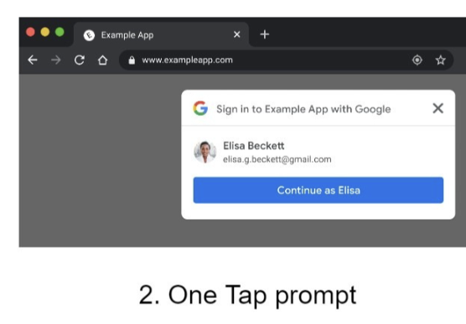
  - Existing Users
    - will be able to click the Sign-in with Google (second button)
      - which is a button that if clicked will ignore any information that may have been entered in other fields on this page
      - and will access the existing User account;
      - if an existing User account does not exist, display error message: “*An existing account does not exist, sign-up above.”
      - this page closes and the next page that opens will be "My Matches'.
  - Considerations for 2.0+
    - PRO users can select multiple locations, to increase search area
    - all users can sign-in with other options such as Facebook, Instagram, WhatsApp

- My tags page

  - Free version
    - This page opens when:
      - 'Sign-in with Google' (first button) on Landing Page is successfully clicked, or
      - "My Tags" icon is clicked by an existing User who is on the free version via the sidebar navigation.
    - 5 tag fields are displayed:
      - which for an existing User, will contain information (tags) previously entered, in the same order entered;
      - but for a new User, will appear as empty free-text fields.
      - when any tag field is clicked upon, it opens up the mobile keyboard on a mobile or tablet device
      - and requires the User to enter
        - a minimum of 2 and a maximum of 20 characters
        - Consisting of ‘Latin script’ lowercase alphabets, numbers and spaces only. Symbols and underscore will not be accepted. (MVP)
        - The system will auto-change anything entered in uppercase/capitals into lowercase i.e. even if User types in uppercase, it will appear on User’s screen and recorded in system as lowercase (can this be done? Otherwise, set a rule that the algo is to ignore any capitalisation/make it not case-sensitive. The thing here is I don’t want ‘Football’ and ‘football’ to be stored as two separate tags in the system, even if they match, I want them to have the same TAG ID)
        - the system should ignore any spaces mistakenly entered before or after the tag so that user error does not affect the system’s ability to match. E.g. the system should record ‘ football’ or ‘football ‘ as ‘football’.
        - The system should consider two or more consecutive spaces only as one space (a type of user error) e.g. tag entered as ‘ballroom dancing’ is recorded as ‘ballroom dancing’
      - if respective tag field not entered successfully after first attempt, display error message: "*Tag must contain between 2-20 characters consisting of only letters, numbers and spaces."
      - A User is permitted to enter the same word in multiple tag fields. For example:
        - C is a free user and D is a PRO user who has set his ‘minimum number of matching tags’ rule to 1
        - C’s tags are ‘single’, ‘dates’, ‘coffee’, ‘30s’ and ‘morning’.
        - D chooses to enter 5 tags as ‘single’, ‘single’, ‘single’, ‘single’ and ‘single’.
        - Users C and D will not be matched by the system because although the rule is satisfied for D, the rule is not satisfied for C (free user, rule = minimum 2).
        - if C becomes a PRO user and also sets her ‘minimum number of matching tags’ rule to 1, the system will match Users C and D.
      - Once users are matched, changing tags will not unmatch users. To unmatch users, any one of the two users is required to click the ‘unmatch and delete’ button.
      - The algo is able to use a tag more than once for matching to meet the ‘minimum number of matching tags’ rule. Continuing from the example above AND assuming Users C and D have yet to be matched by the system:
        - C and D continue to use the same tags as above
        - D changes his ‘minimum number of matching tags’ rule to 2
        - The system will match users C and D by matching two of D’s tags: ‘single’ and ‘single’ with one of C’s tags: ‘single’ twice.
      - After a User enters the first tag field successfully i.e. without error, the User should be able to hit the RETURN key, to type into the second tag field, and so on.
      - If there is information already contained in the second tag field, that information will be highlighted, and if a User types any one character, this will replace the information that exists
      - Hitting the RETURN key after completing the last tag field, should select the START button,
      - and hitting the RETURN key again, should click the START button.
    - Clicking the START button:
      - requires all 5 tags to be correctly completed
      - otherwise display error message in red at designated spot: "*All 5 tags must be completed."
      - successfully
        - closes this page and opens up the 'My Matches’ page
        - starts the algo to query for matching tags of other users in the same Location.
        - displays Matched-Users on the ‘My Matches’ page, if a match occurs
    - The ‘minimum number of matching tags’ is set to 2 by default for free accounts. This means that for a User to match with a Matched-User, 2 or more of the User’s tags must match with that of the Matched-User.
    - A directory of ‘banned tags’ needs to be built:
      - where I can ADD and REMOVE ‘banned tags’ over time
      - BEFORE the algo searches for a match, ALL of a User’s tags will be screened against this directory and IF there are ANY ‘banned tags’, these ‘banned tags’ will NOT be used in the search. The search will still continue with the User’s other tags.
      - A User WILL be permitted to enter a banned tag on their ‘My tags’ page, and will NOT be informed by the system when they have entered a banned tag.
      - Let me know when you require this list of ‘banned tags’ and I will provide it to you.
    - In the spot for the first tag, include a placeholder that disappears once User starts typing. Placeholder should state: “Enter your first tag here”.
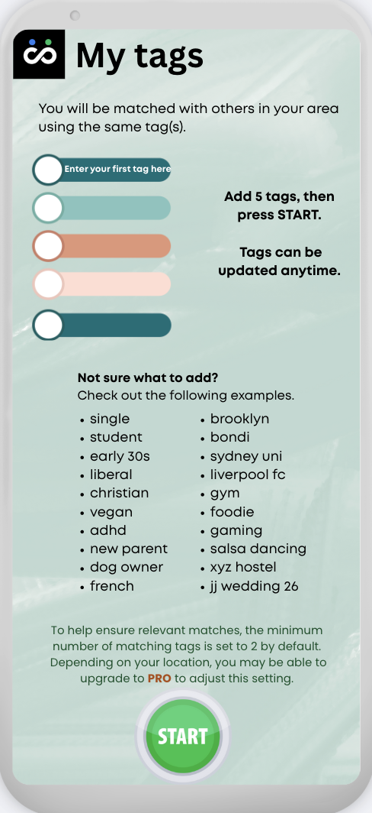

Image below (old version) only shows where error messages are to be displayed. Refer to new version above for content.
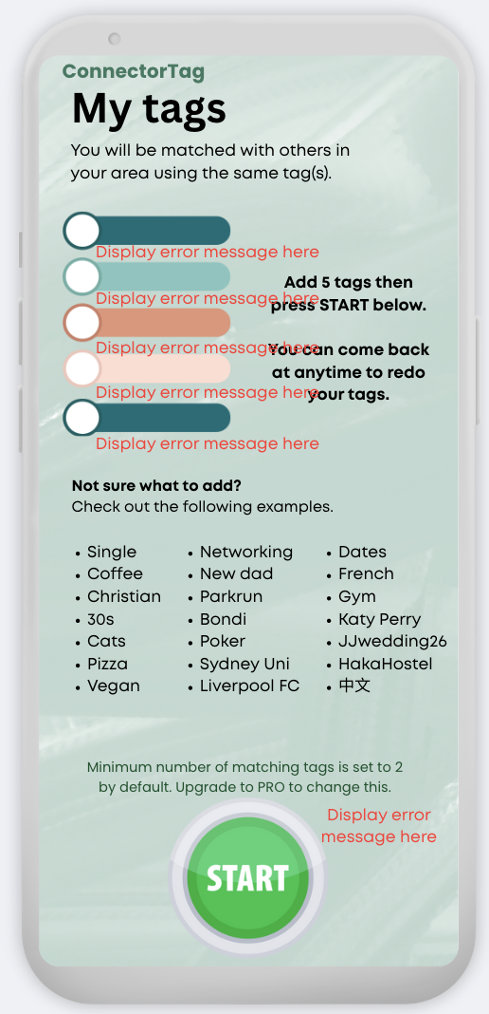

  - PRO version
    - has 12 tag fields displayed, and allows a User to complete a minimum of 5 and maximum of 12 tags to run a search.
    - any empty tag fields are not included in the search query i.e. they do not match up with empty tag fields of other users.
    - User is able to set ‘minimum number of matching tags’, to a minimum of 1 and maximum of (12 matching tags OR number of tag fields completed, whichever is lower).
    - Other functionality including tag field requirements from the free version continues in the PRO.
    - Location of error messages as per free version.
    - Clicking the START button:
      - requires a minimum of any 5 tags to be correctly completed (both PRO and free requires minimum 5 tags to be completed)
      - otherwise display error message in red near the START button: "*At least 5 tags must be completed."
  - Considerations for 2.0+
    - PRO users can re-order their tags i.e. move tags up and down the list, without having to delete and re-type tags
    - PRO users can require certain of their tags to be matched (must match)
    - PRO users can hide certain of their tags (hide tag) from:
      - being revealed to Matched-Users (once the functionality of PRO users being able to see which of their tags matched with which Matched-User is introduced), and from
      - being used in the Popular tags page
    - The white circle to the left of a Tag field :(this is just an idea, not really necessary especially if we are changing the final design)
      - to turn green, if a Tag has been correctly entered.
      - to remain white, if Tag field is empty
      - to turn red, if a tag field is incorrectly entered.

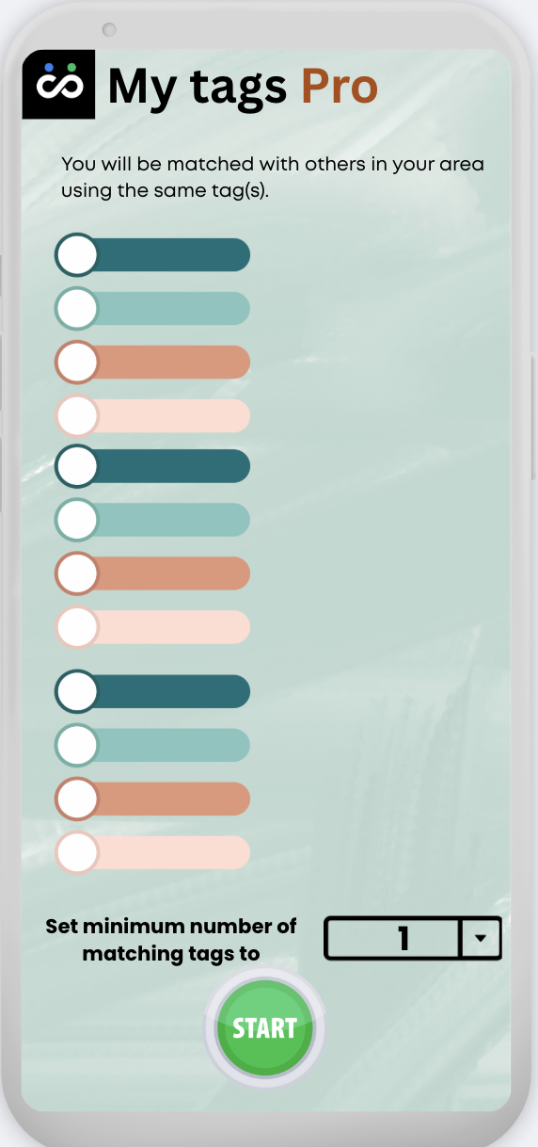

- Popular tags page

  - Has been simplified to only show the top 20 tags used, based on location selected, excluding ‘Censored tags’. This means that Users in the same location will see the same popular tags page. A user in a different location will see a different version of the page with different tags.
  - Will automatically be populated by the system (i.e. no manual work for Admin)
  - There is a requirement for tags to have at least 20 counts (20 instances of this tag currently being used in said location) to appear on the Popular Tags page. This is to prevent privacy issues when there are new locations/low users.

  - A directory of ‘censored tags’ needs to be built:
    - ‘censored tags’ will still be used by the algo in searches to find a match, but will not appear in the ‘Popular tags’ page due to their sensitive content.
    - all ‘banned tags’ are ‘censored tags’
    - but not all ‘censored tags’ are ‘banned tags’.
    - When a tag is added as a new ‘censored tag’, if it appears on the ‘popular tags’ page, it will no longer appear on the ‘popular tags’ page, and the tag with the next highest count (usage/popularity) in that location will appear.
    - Let me know when you require this list of ‘censored tags’ and I will provide it to you.
  - Considerations for 2.0+
    - All users can click on any of the tags shown on the ‘Popular tags’ page to directly add them to any empty tag fields in ‘My Tags'.
    - At some stage, when a user enters a tag on the ‘My Tags’ page, they will be able to see the number of users in their location using the same tag e.g. when they type ‘swim’ a number will pop up saying (420) identifying that this tag is currently being used 420 times and it may recommend ‘swimming’ (700) so the user will get to choose. A user may not always choose the larger amount e.g. ‘netball’ (800) and ‘xyz netball club’ (100) if they want to connect with only a certain group
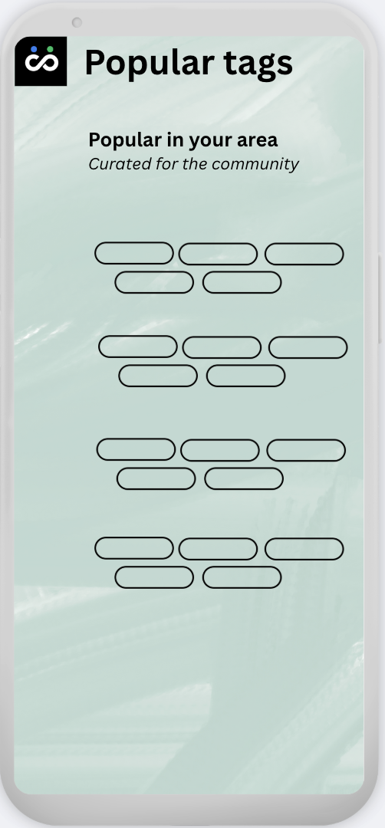

- My matches page

  - If User has no Matched-User and is using the free version, display as follows
    - This will likely be the screen a new user will see after clicking the big green button to run the search.
    - An existing user (free version) may also come back to this screen if they choose to delete all their Matched-Users.
  - Priority of searches rule: When the system searches for matching tags e.g.
    - Pro users first until they have at least 6 new Matched-Users every 24 hours
    - Then free users, for 2 new Matched-Users every 24 hours
    - And then go back to the top (6.2.1) pro users again to find another 6 new Matched-Users and the cycle repeats, so that Pro users get more matches, especially if the system becomes overloaded in future..
  - I want to prevent the issue of the system getting stuck on finding matches for a user that enters tags that are very unique/not popular and no Matched-users are found easily. So I think there should also be a system time limit for finding matches per user (e.g. 1 minute) before the system gives up on that user and moves on to try to find matches for another user, so that the system does not become stuck.
  - Your thoughts please on 6.2 and 6.3 for MVP stage. Let me know if not necessary based on the way you design the system and at what x number of active users in 1 location do you expect that there will be these issues.

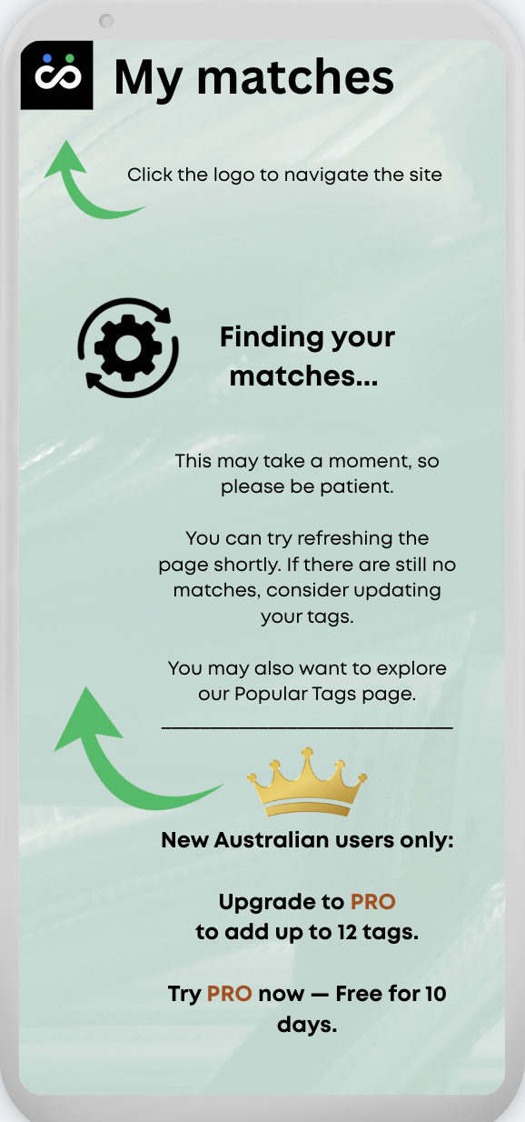

  - If User has no Matched-User and is using the PRO version, display as follows
    - Minor wording changes from above

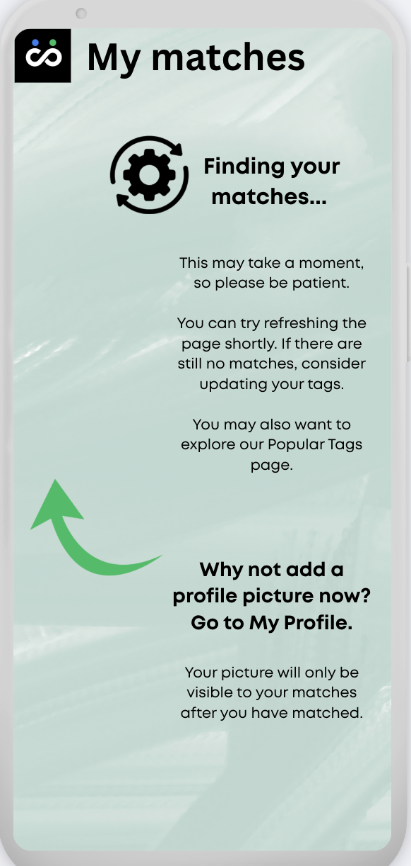

  - If User has at least one Matched-User, display as follows
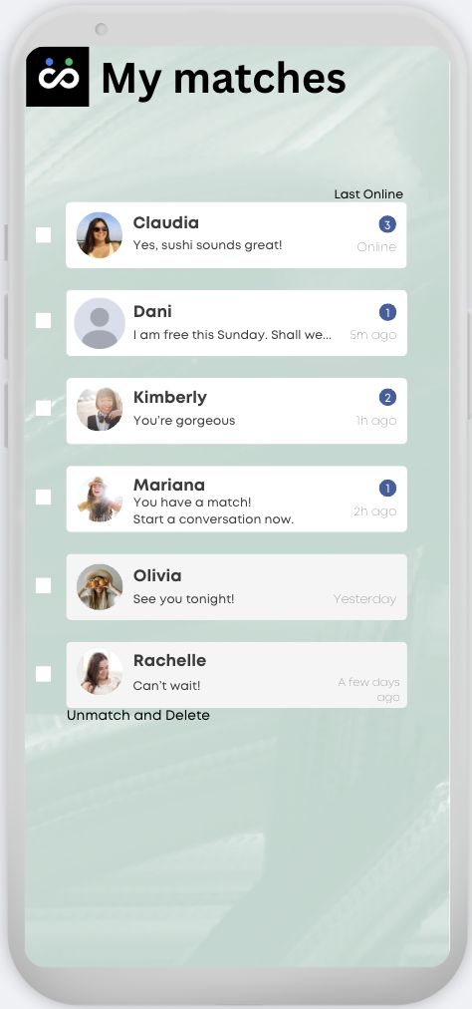
In image above, ignore the number in the blue circle. No need for number in MVP stage. Just blue circle to mean there are unread messages.

I also want to include a link at the top of the page called “Staying Safe Online”. When this is clicked, it will open a modal pop-up box.

    - When User and Matched-User are first matched by the system
      - the following words are displayed for both User and Matched-User as shown for Mariana: "You have a match! Start a conversation now." and the blue circleis shown
      - both users are able to instantly message each other, there is no need for both sides to accept the match first
    - Once User and Matched-User are matched, changing the tags and running the search again will not affect the match, users will remain matched until one of them chooses to ‘unmatch and delete’. When any user clicks this, the match is deleted, and any messages previously sent are deleted from view of both users. Both users will no longer be able to see or message with each other in ‘My Matches’.

    - Each box is the same size, so longer messages will be cut off with a … or just cut off in the preview page.
    - If all messages have been read by User, no blue circle is shown and only the last message is displayed (e.g. Olivia)
    - Profile picture of Matched-User is shown, otherwise greyed out headshot is used (e.g. Dani)
    - User can click anywhere within the white boxes including profile pic/name:
      - to close this screen
      - and open the 'My messages' screen for the relevant Matched-User
    - Matches are sorted based on the Matched-User's last online time. Examples are shown:
      - 'Online' if Matched-User currentlyhas the webapp open
      - '5m ago' if Matched-User was last online 5 minutes ago, and use this format for <60 minutes. Code display number to change accordingly
      - '2h ago' ....for 2 hours ago, and use this format for >=60 minutes and <24hrs. Code display number to change accordingly
      - 'Yesterday' for between 24-48 hours ago.
      - 'A few days ago' for >48 hours ago
    - User can check (multiple at once) tickbox on left side and click 'unmatch and delete' to delete the match and conversation.
      - After successful deletion, display the following message under the 'My Matches' heading in green colour,
"Unmatched successfully! However, you may match again in future if your tags connect. We are working to bring you Block and Report functionalities."
    - Considerations for 2.0+
      - All users
        - 'Pin match to top' functionality to pin certain Matched-Users to always appear at the top of the screen
        - 'Block' functionality to prevent any future match between User and Matched-User
        - 'Report' functionality to send both user's details to Compliance for further investigation including User’s reason for reporting and history of messages
        - 'Delete conversation' functionality to delete conversation on User’s display, but continue to remain matched with Matched-User
        - Golden star appears after Matched-User’s name if at least 5 tags match (just an idea)

      - - PRO users
        - Able to see which tags matched with which Matched-User (unless one of the users chose to ‘hide tag’)
        - Search bar at the top of page to allow User to search for name of Matched-User or words used in messages
      - In future, I may want the ability to limit the number of matches per day to users, so that they get x maximum number of matches every day, rather than 100 matches on day one and nothing over the following days. Pro users should get more matches than free users.
      - I may also want the ability to give new free users more matches than older free users, for a certain time e.g. first 2 weeks.

- My messages page

  - This page opens when a User clicks on any white space on the 'My Matches' page
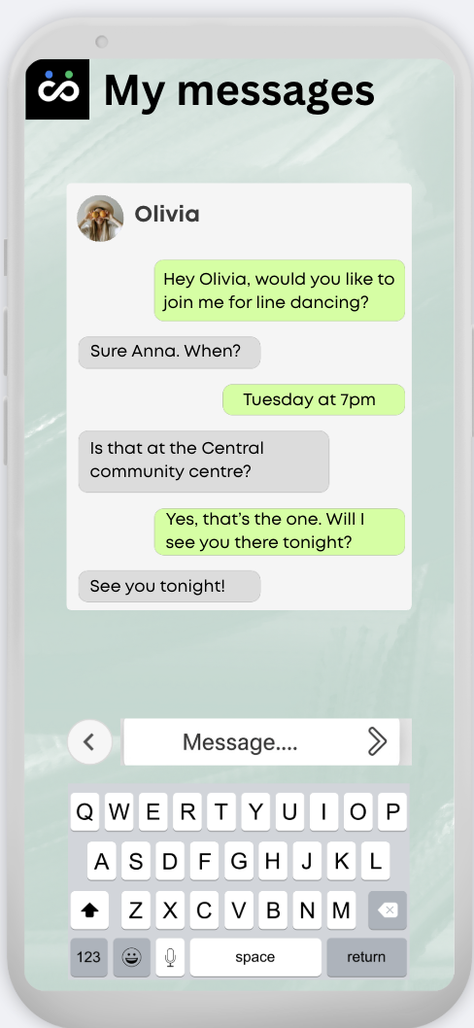

  - is unique to each Matched-User (e.g. if User has 6 matches, there needs to be 6 different My Messages pages).
  - Name and profile picture of Matched-User is shown at the top. This will automatically change to the latest version if Matched-User changes their display name or changes/removes their profile picture.
  - All prior messages are shown. If message thread exceeds screen size, a scroll bar on the right appears and by default the bar scrolls to the bottom when this page opens, to show the most recent messages. The font size does not get smaller but remains the same. In this case, the profile picture and name of Matched-User remains at the top and is not part of the scroll bar.
  - Clicking on the white ‘Message...’ box at the bottom:
    - opens up the mobile keyboard on a mobile or tablet device;
    - allows User to enter characters, spaces, numbers and symbols, to a limit of 120 per message or whatever you think is suitable. This is really not that important to me, just want to prevent spamming of really long messages. If it is easier to code for the user to be able to message using any script, please do so, otherwise Latin characters, numbers and spaces only, allow capitalisation.
  - Clicking the right arrow button:
    - when nothing is typed in the ‘Message....’ box results in nothing happening;
    - when there is at least one character typed in the ‘Message....’ box
      - results in the message being sent to the Matched-User
      - after which the sent message appears at the bottom of the thread and the Message box reverts to as shown with "Message...."
  - Clicking the left arrow button OR if the user swipes left from the right side of a mobile or tablet device:
    - ignores anything remaining in the ‘Message....’ box that was not sent
    - and closes this screen to return to 'My Matches' screen
  - Considerations for 2.0+
    - Ability to send emojis
    - PRO users are able to attach images from the device gallery
    - Ability to react to each sent message with an emoji
    - Time-stamp on each message
    - Read/unread status per message on this page
    - Ability to clear chat history on the User's screen
    - Ability to share an invite link for group messaging
    - Ability to unsend messages if unread by Matched-User
    - Spell-check and auto-suggest words
    - PRO users can video/audio call with other PRO users who are online

- Upgrade to PRO page

  - New user wording
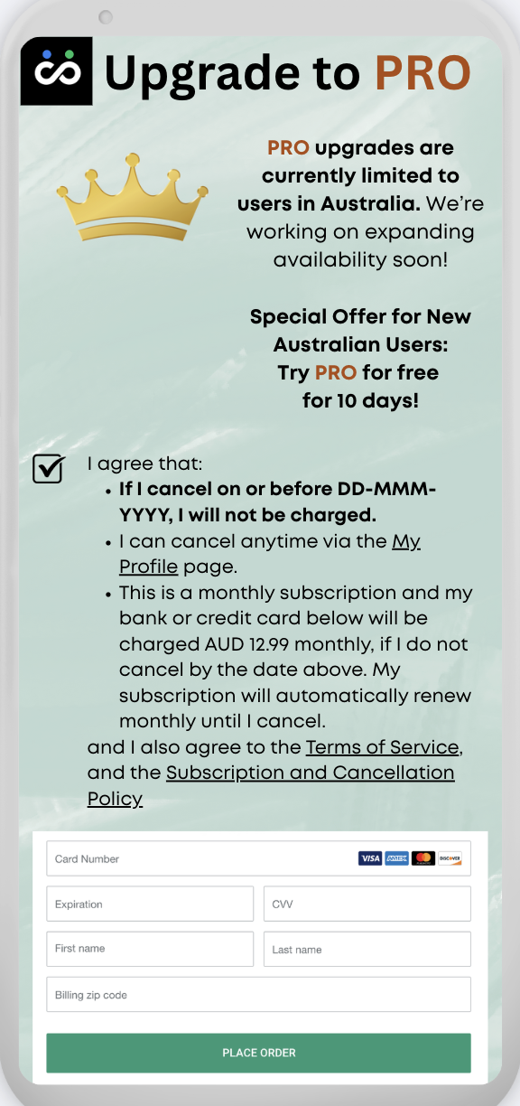
    - this page opens when:
      - a User clicks on 'Upgrade to PRO' icon in the sidebar navigation, AND
      - ONLY IF the user has never previously used the free trial
    - date and time zone used is to be that as per user’s location selected
    - Refer to 1.3 above on how to limit this to users in Australia only for MVP
    - Integrate payment with STRIPE
    - The field DD-MMM-YYYY
      - requires the month to be in letters, not numbers (e.g. if today is 14-JAN-2026) to prevent confusion with US format.
      - is not today's date, but is auto-calculated as today's date plus 10 days (e.g. 24-JAN-2026)

    - Do not hard-code the price (12.99), currency (AUD) and number of free trial (10) days. I want the ability to change these in future, based on country
    - Clicking the link to ‘My Profile’ page opens up another browser tab.
    - Clicking the links to “Terms of Service” and “Subscription and Cancellation Policy” will open as a modal pop-up, with an X at the top-right to close it.
    - User must check the tickbox which initially appears as an empty square before they can proceed with payment, otherwise display error message “Tick the box to agree then proceed with card details”

    - Clicking on 'Place Order' checks that all credit card fields are entered correctly and proceeds with payment via Stripe.

    - After the user successfully places an order, the system will automatically send a PRO Subscription Email to the user’s email address. Wording for this email will be provided to you, please let me know when you need it. It will contain some coding with dates
This is an example only, I will confirm exact wording later, please let me know when you need it.
your free PRO trial period ends on dd/mmm/yyyy.
If you do not cancel your PRO Subscription by the date above, we intend to deduct your first monthly payment on dd/mmm/yyyy
This is for the Subscription Term of dd/mmm/yyyy - dd/mmm/yyyy
Subsequent payment will be deducted around the same date every month
    - Instead of ‘billing zip code’ in image, use ‘post code’,
      - this field should really be the user’s full address, for e.g. they start typing 1 Sydney Road, and then it shows a dropdown list of addresses that match to choose from
      - Please discuss with me as I think it depends on Stripe integration?
    - Considerations for 2.0+
      - - *important* at some stage, I may want to use this page as a hard paywall i.e. User must accept the free trial to continue, please consider this in the development, possibly for certain countries only
      - expand PRO offering to other countries besides Australia
      - - ability to price in different currencies (AUD, USD, SGD)
      - - ability to have different prices for different locations
      - At some stage, I may decide to use banner ads for free accounts.

  - Free trial used wording
    - this page opens when:
      - a User clicks on 'Upgrade to PRO' icon in the sidebar, AND
      - the user has previously used the free trial
    - Links open the same way as described above (8.1.9, 8.1.10) and user will need to check the tickbox (8.1.12)
    - See 8.1.15, same comment applies re ‘zip code’

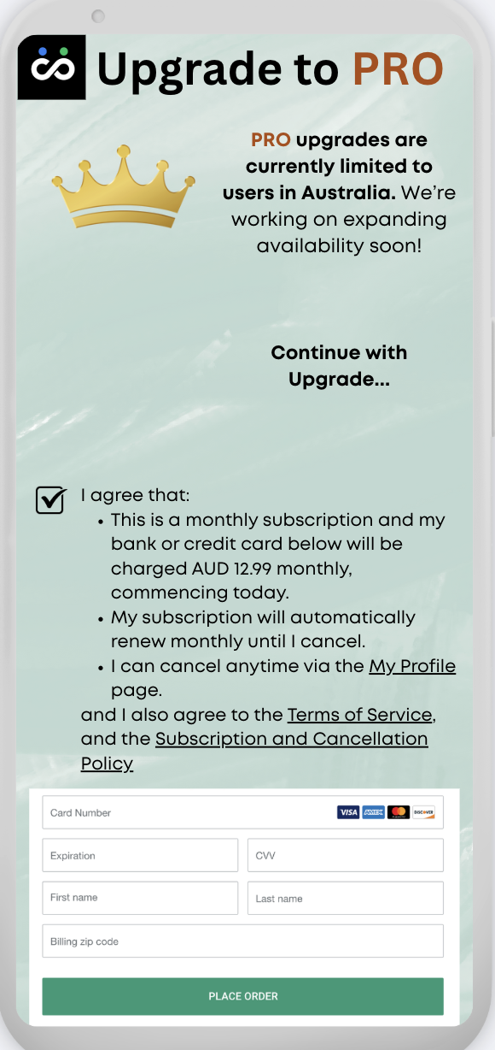

- My Profile page

  - This page opens when a User clicks on 'My Profile' icon in sidebar navigation.
  - 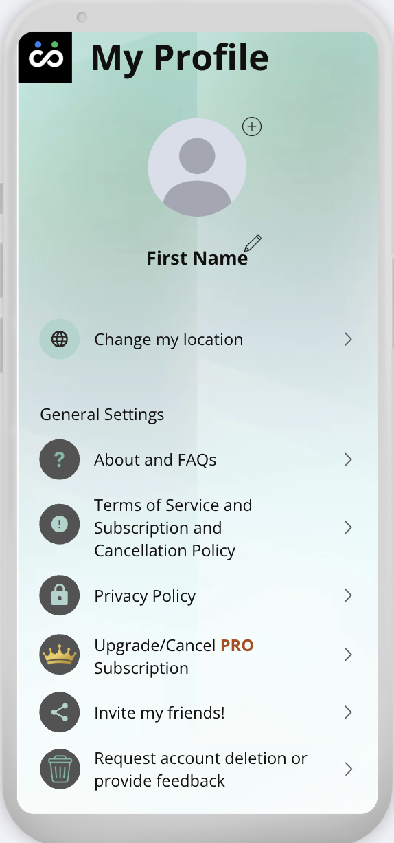

  - (+) button
    - If no profile picture (greyed-out circle is shown by default), clicking the (+) button allows User to upload a profile picture
    - If profile picture already exists, clicking the (+) button allows User to update profile picture. The system will only store one picture at a time.
    - Display the following message to User after user clicks the (+) button, near the Upload button
“1 photo • 1 face • PG only”
    - Run APIs (I have chosen AWS Rekognition below based on price but feel free to recommend others if you feel they are better)
      - First to detect that there is only ONE human face (AWS Rekognition - DetectFaces API)
      - If yes above, then only run next API, check that no nudity, sexual content or violence (AWS Rekognition - DetectModerationLabels API)
  - “First Name”
    - is to display as whatever user enters as ‘first name’ in the landing page during sign-up. Do not display the actual words ‘first name’ here.
  - Pencil icon
    - Clicking this allows user to change their first name/display name.
    - do not allow User to change to a name that is in the directory of ‘banned names’

  - Change my location
    - would allow a User to change their Location from that which was selected during sign-up to one of the other ten locations
      - the algo stops searching in the old Location and starts searching in the new Location based on the User’s existing tags
      - any existing Matched-Users will continue to be matched with User
      - This does not affect free/PRO status. For example, a PRO Australian user may go for a holiday to New York and temporarily change his location from Sydney to New York. He will still be a PRO user.
  - About and FAQs, Terms of Service and Subscription and Cancellation Policy, and Privacy Policy
    - will open as separate modal pop-ups, with an X at the top-right to close it.
    - I will provide the wordings for these, let me know when you need it.

  - Upgrade/Cancel PRO subscription
    - if a free user,
      - it will be equivalent to clicking the ‘Upgrade to PRO’ icon in the sidebar i.e. open to this page
    - if a PRO user,
      - to ask User:
“Are you sure you wish to cancel your PRO subscription?
In line with our Subscription and Cancellation policy, if you cancel now, we will immediately cease billing you for any future amounts. For amounts already billed or paid, no refunds or credits are provided, but you will continue to have access to PRO features until the end of your current billing period.”
      - with options to click “Continue using PRO” or “Cancel my PRO subscription”.
      - After the user successfully cancels their subscription, the system will automatically send a Pro Cancellation Email to the user’s email address. Wording for this email will be provided to you, please let me know when you need it. It will contain some coding with dates
E.g. You have paid until dd/mmm/yyyy and you will continue to have access to Pro features until this date.

  - Invite your friends! (Optional - can this be implemented easily?)
    - allows a User to easily send the message below to any contact through WhatsApp, FB Messenger or SMS Message (if they have it logged-in on the device they are using):
”I am using ConnectorTag. Try today for free!
www.connectortag.com”
  - Request account deletion or provide feedback
    - Clicking this opens a modal pop-up with the words “To request account deletion or to provide feedback, kindly email us at support@connectortag.com”
And an X at the top-right to close the modal pop-up
  - Considerations for 2.0+

    - provide feedback through the app instead of email.
- Super admin page
  - No fancy dashboard required - as basic as possible
  - Google login for super admin
  - Admin requires the following ability for MVP:
    - Ability to export data in CSV format:
      - Tag database
      - Users database
      - Matches database
      - Subscription management (Stripe?)
    - Take following actions manually:
      - Tag database
        - Add new tag (usually a new tag is created when a user creates a tag that does not match any existing tags in the system, but when this business initially starts, I will need to compile a list of banned/censored tags, so I will need the ability to add them as new tags since they have not been used by any user yet)
        - Add Tag ID to the directory of ‘banned tags’ (which auto adds to ‘censored tags’ too because every ‘banned tag’ is by definition a ‘censored tag’)
        - Add Tag ID to the directory of ‘censored tags’ only
        - Remove Tag ID from the directory of ‘banned tags’. Tag ID will remain a ‘censored tag’
        - Remove Tag ID from the directory of ‘censored tags’
      - Users database
        - Delete user (and their data) - when admin receives an email from user requesting admin to do so.
        - Delete/reject profile picture (if API fails)
        - Ban/unban user
        - Change subscription status of user (free/pro)
      - Matches database
        - Unmatch - in the case where system error or user makes a report

      - Subscription Management (Stripe?)
        - View subscription records
          - Active PRO users
          - Renewal dates
          - Churned users
          - Payment failures
        - Actions
          - Manually cancel subscription
          - Manually grant free PRO
          - View invoices
        - Integrations should support:
          - Google login + Stripe customer mapping
          - AUD12.99/month subscription plan
        - Ability to easily export all data across from Stripe/database to another payment processor, if we are suddenly banned from using Stripe for some reason
  - Tag database
    - required fields at minimum:
      - Tag ID
      - Tag name
      - Usage count (sorted by descending order)
      - Banned tag (yes/no)
      - Censored tag (yes/no)
    - ability to filter by location but also option to aggregate for ‘ALL locations’, example below (see note on filter below)
    - And it should auto-sort by count (descending order) i.e. number of times tag is currently being used, i.e. do not count previously used tags (i.e. tags that a user may have used in the past, but is no longer using).
    - The ‘popular tags’ page will query this database (i.e. top 20 tags that are not censored, filtered by relevant location). Please note, super admin page does not require filter function to be built, I am happy to export to CSV and filter it that way to save on cost.
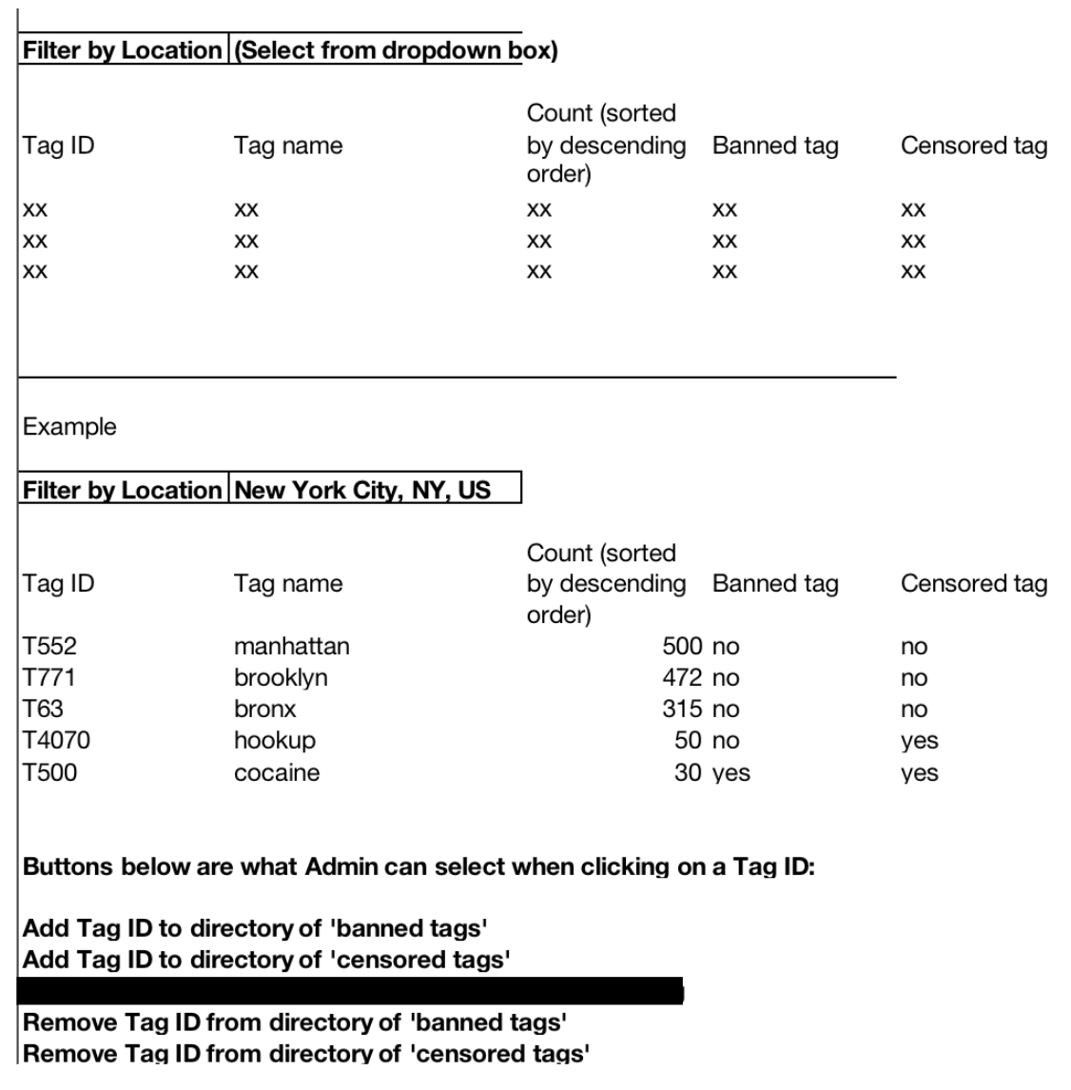
  - Users database
    - required fields at minimum:
      - Google user ID (use as our user ID)
      - Email address (from Google sign-in)
      - First and last name (from Google sign-in) - two separate fields
      - First name/Display name (chosen by user during sign-up)
      - PRO user (yes/no)
      - Profile picture (yes/no) and ability to view file
      - Account status (active/deleted/banned)
      - Current city
      - Current tag(s)
      - Number of matches (currently matched, unmatched)
      - Match ID(s)
      - Number of messages sent
      - Date-timestamp of sign-up
      - Date-timestamp(s) of pro subscription
      - Date-timestamp(s) of pro-cancellation
      - Last active date-timestamp defined as most recent log-in/tag updated/message sent. If user has browser tab for CT open and currently running in background, consider this still logged-in.
  - Matches database
    - required fields at minimum:
      - Match ID
      - User IDs of matched-users (A and B)
      - City/location of match
      - “Minimum number of matching tags” of both users - two fields
      - Tags of matched-users (I was thinking this should be all the tags of both users, not only the matching tags, so that we can test the algo?)
      - Date-timestamp(s) of match creation
      - Date-timestamp(s) of match deletion
      - Reason for deletion (deleted by user A/user B/or admin)
  - Directory of ‘banned names’ : referring to the First Name a user is not allowed to use, referred to in section 3.4.2.6
    - Admin is able to add and remove words from the directory of ‘banned names’.
    - This directory will include all ‘censored tags’
    - And some others like the words ‘admin’, ‘user admin’, ‘official account’, ‘Connector Tag’, ‘connectortag’
  - Directory of ‘censored tags’
    - Admin is able to add and remove words from the directory of ‘censored tags’.
    - This directory will include all ‘banned tags’
  - Directory of ‘banned tags’
    - Admin is able to add and remove words from the directory of ‘banned tags’.
  - Waiting List
    - See 3.4.1.2.4, this will be if user enters a city and their email address to ask to be notified when we are in their location.
  - Moderation Tools
    - Admin does not need to read message content for privacy reasons so
      - View metadata only by default (timestamps, counts)
      - Only view message content when a conversation is flagged by a user
  - Considerations for 2.0+
    - Directory of Locations - add/remove locations from the list.
    - Ability to freeze messaging for a user instead of suspending them
    - User flag and reporting functions
    - Merge/unmerge tags (e.g. ‘swim’ and ‘swimming’)
    - Database of Users
      - breakdown of active/inactive users
      - For inactive user accounts, ask system to stop searching for matches for them and stop using their tags in the count for ‘popular tags’

